Initial Dashboad

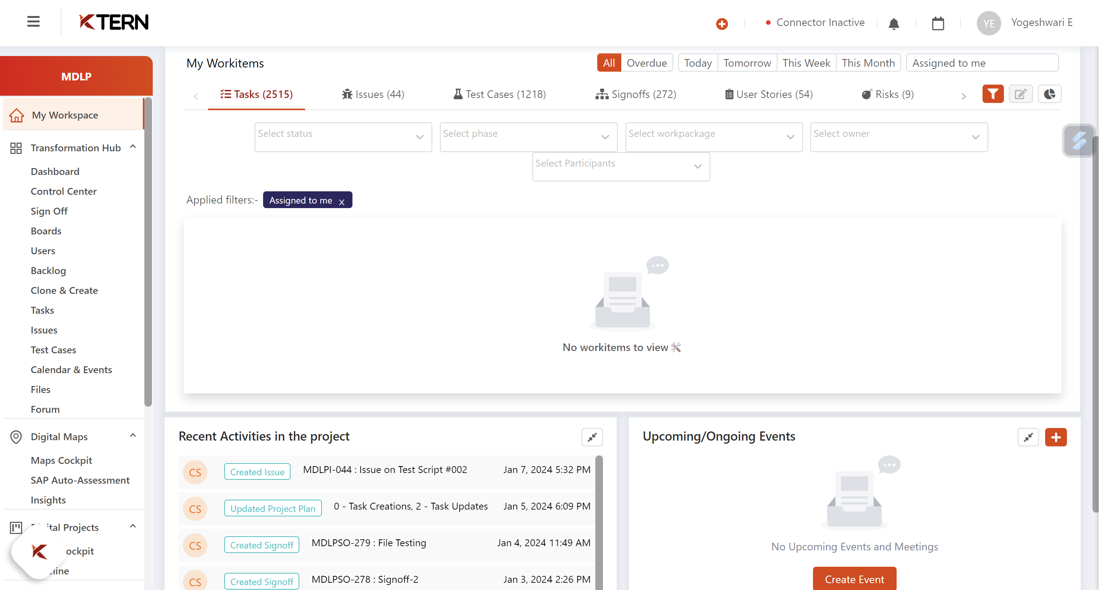

Here, the user can see all the tasks, issues, testcases, risks related to project and also can view the recent activities, upgrades or tests that has been implemented. The workspace is used to view the tasks that is assigned to us and the status of the tasks.

Digital maps

Bots providing assessments for providing useful insights.

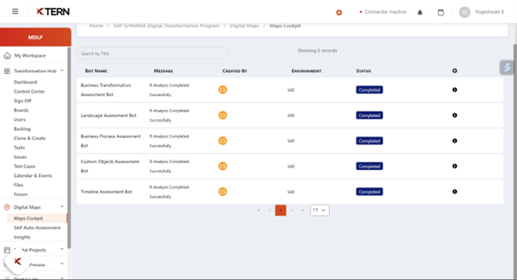

Showing active and inactive users, in order to optimise the users.

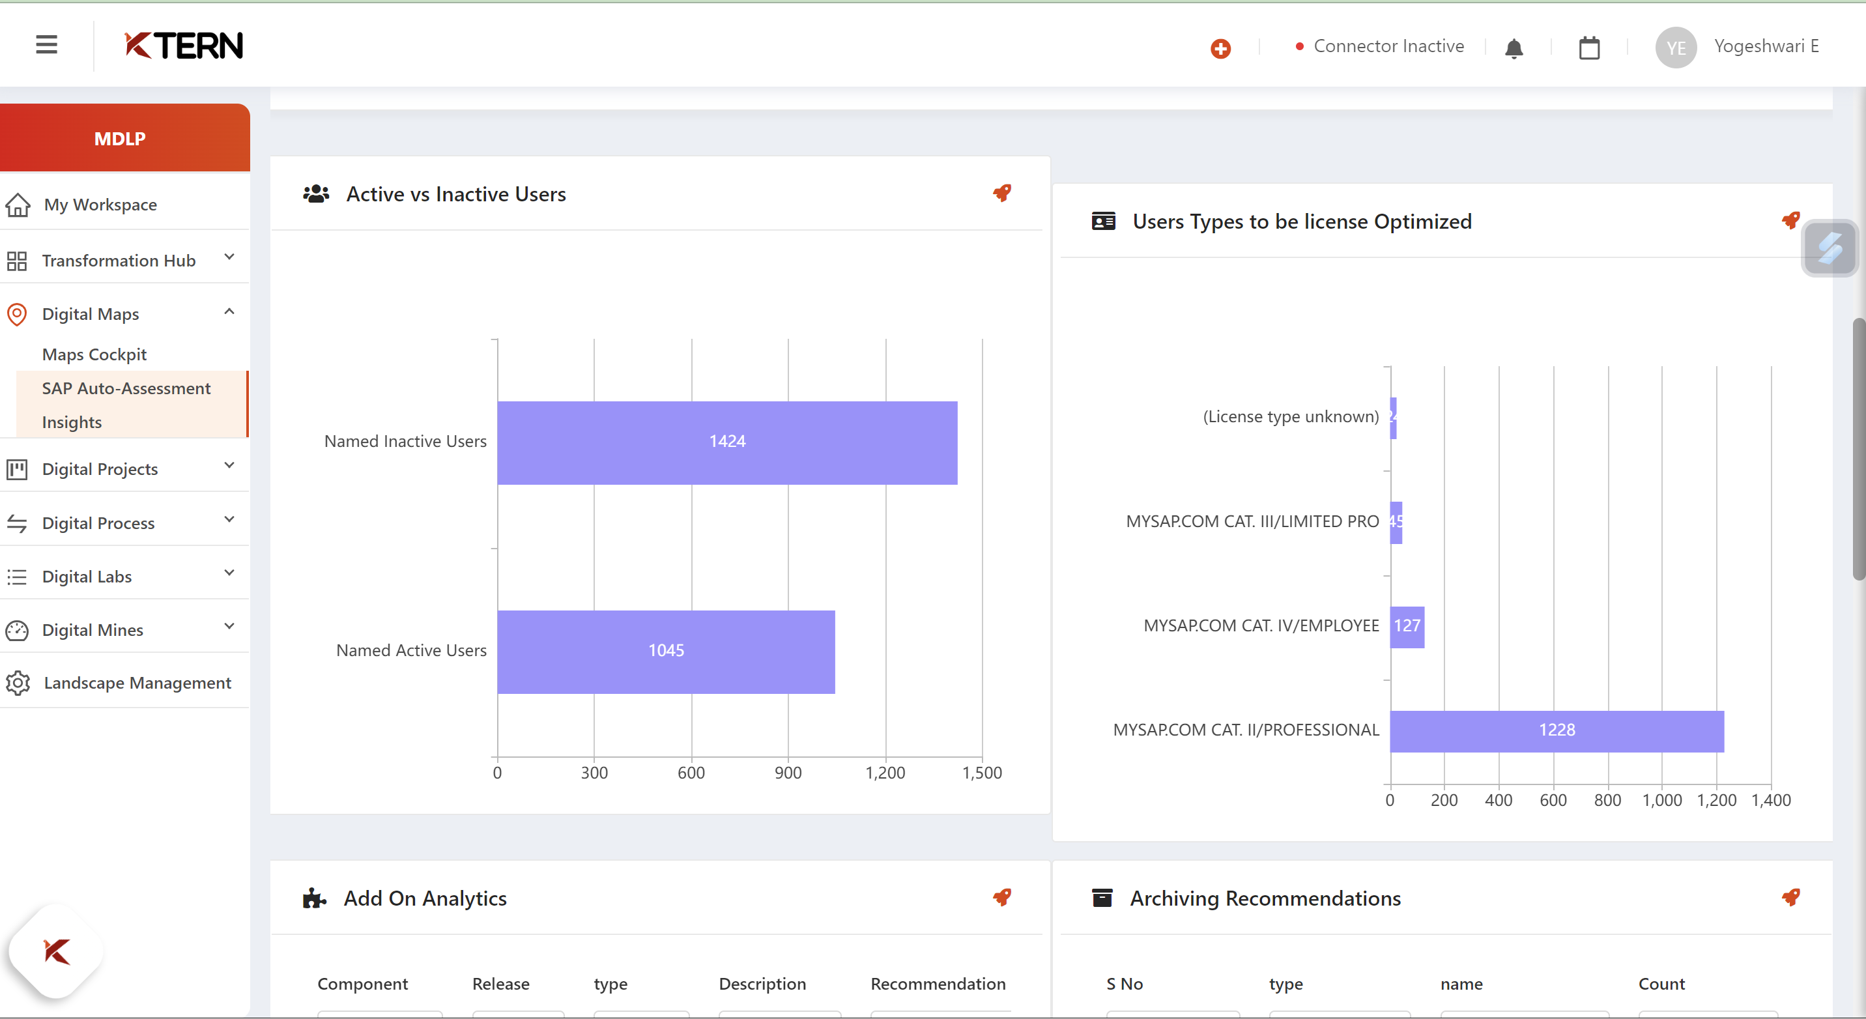

MATERIALITY ANALYSIS.

Graph showing the different requirements from each modules of sap.

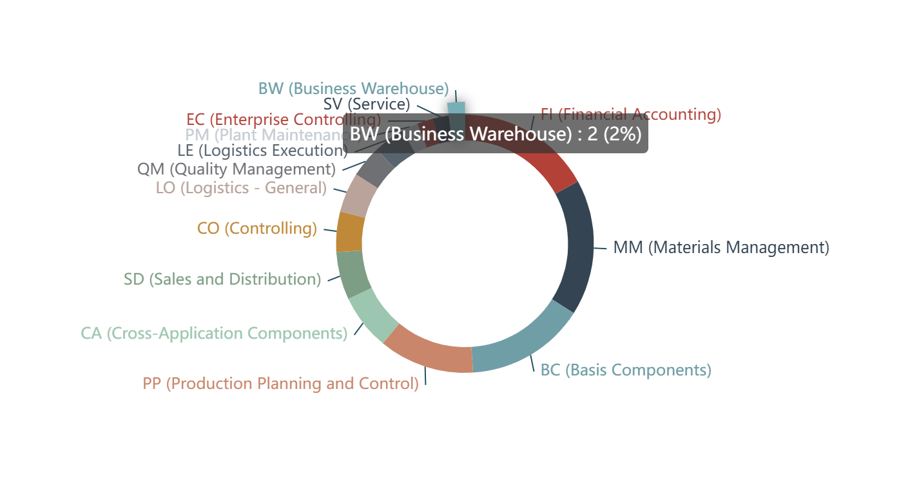

Lifecycle involved in projects and the progress is shown in 2 phases as wave 1 and wave 2, where the utmost care needs to be taken .

Digital project

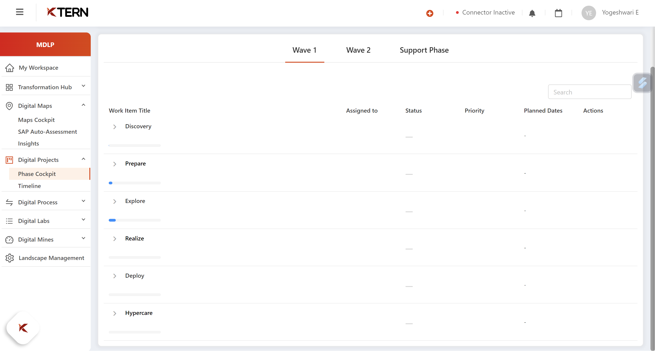

The above stated discovery, prepare, explore, realise, display and hypercare phases are scheduled under timeline where the giant tasks are tiny parted in order to achieve the higher level tasks.

The work breakdown structure demonstrates the hierarchy of activities to be performed.

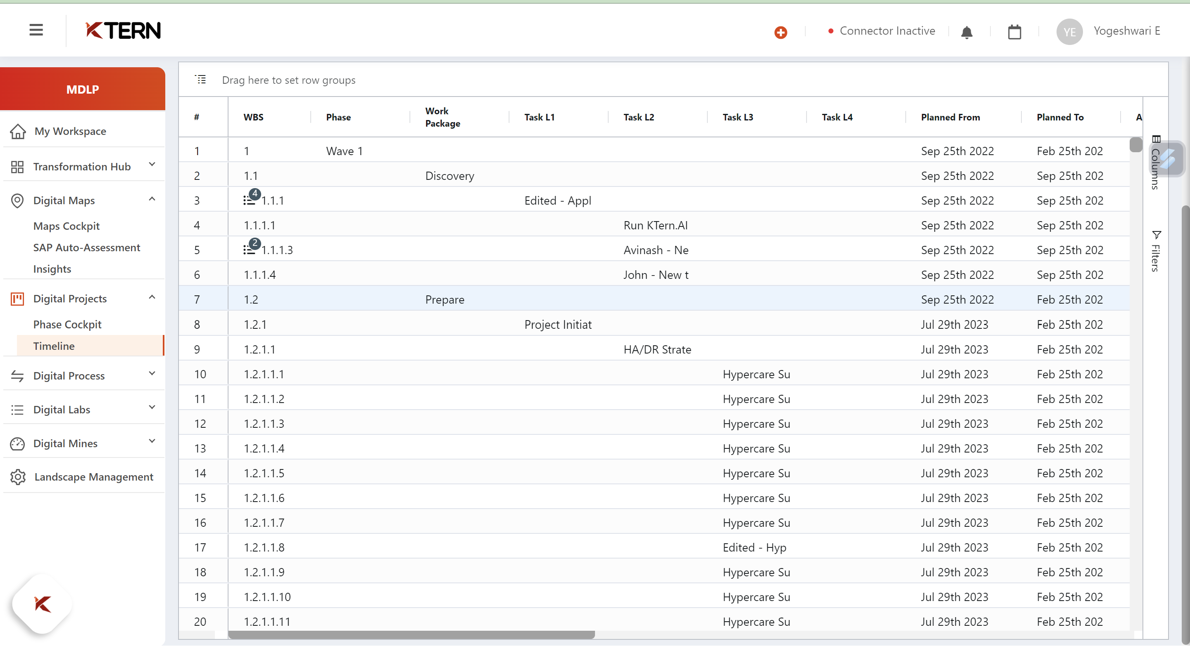

Digital process

This stream is essentially for the maintenance phase, we can clearly maintain the progress of the projects and the stakeholders who involved in the process and their contribution.

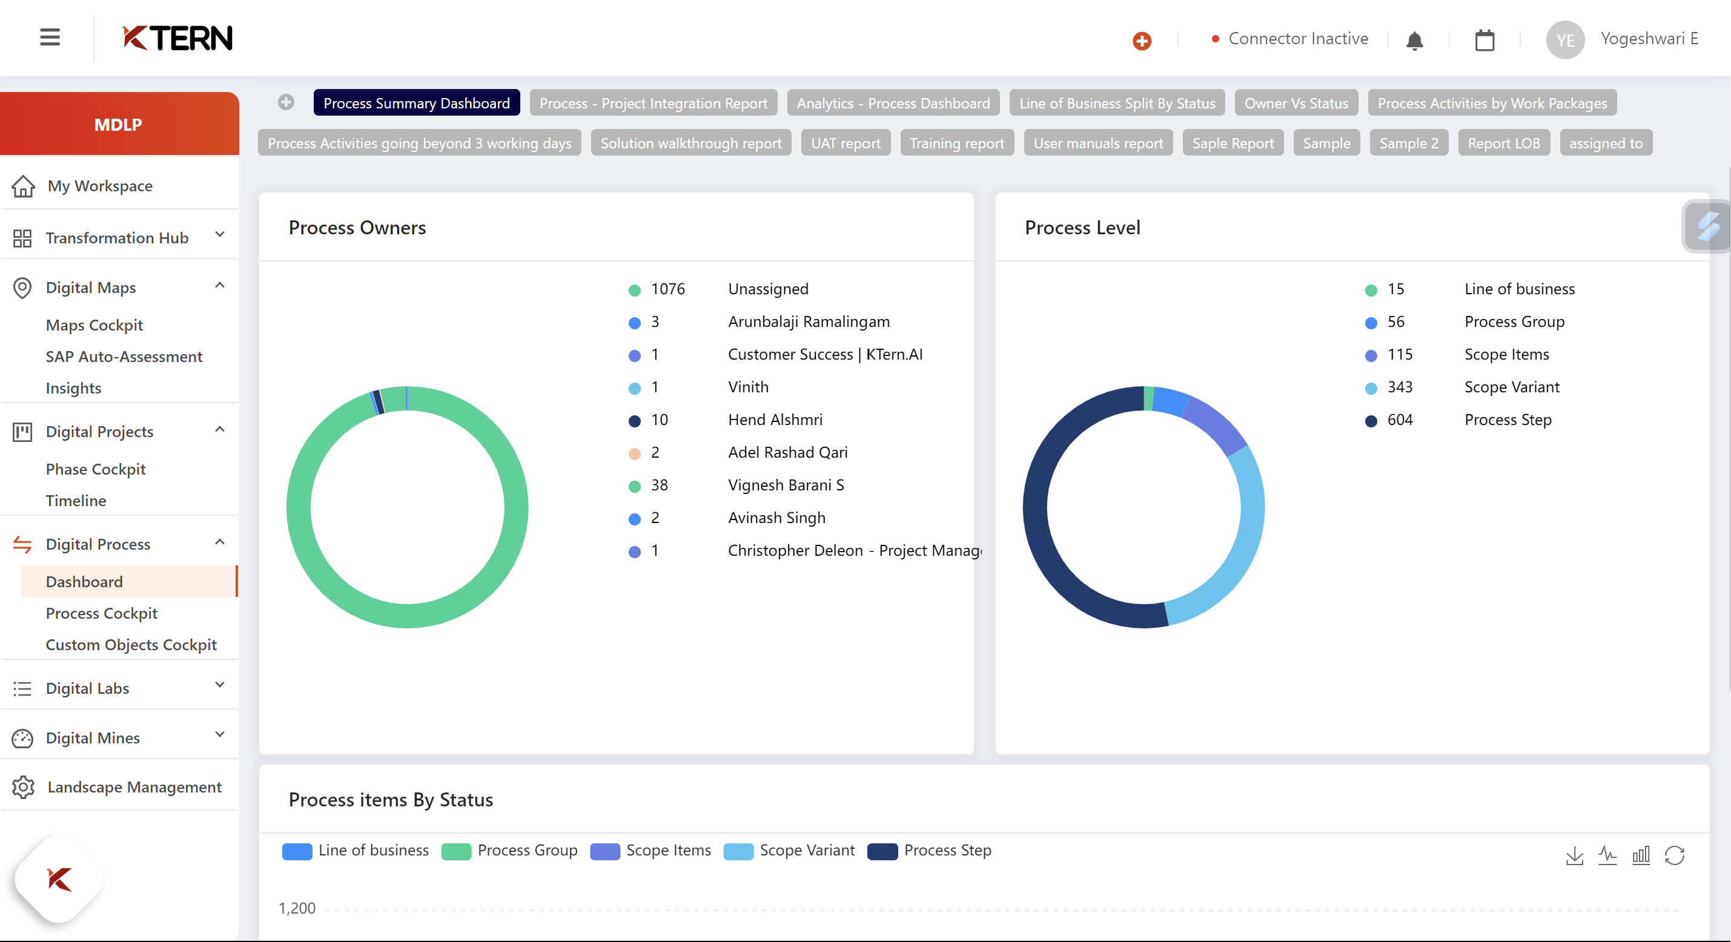

Project integration Report

This evidently shows us the integrated status of the entire project. This gives the clear picture and the tasks that needs to be completed, needs approval, etc…

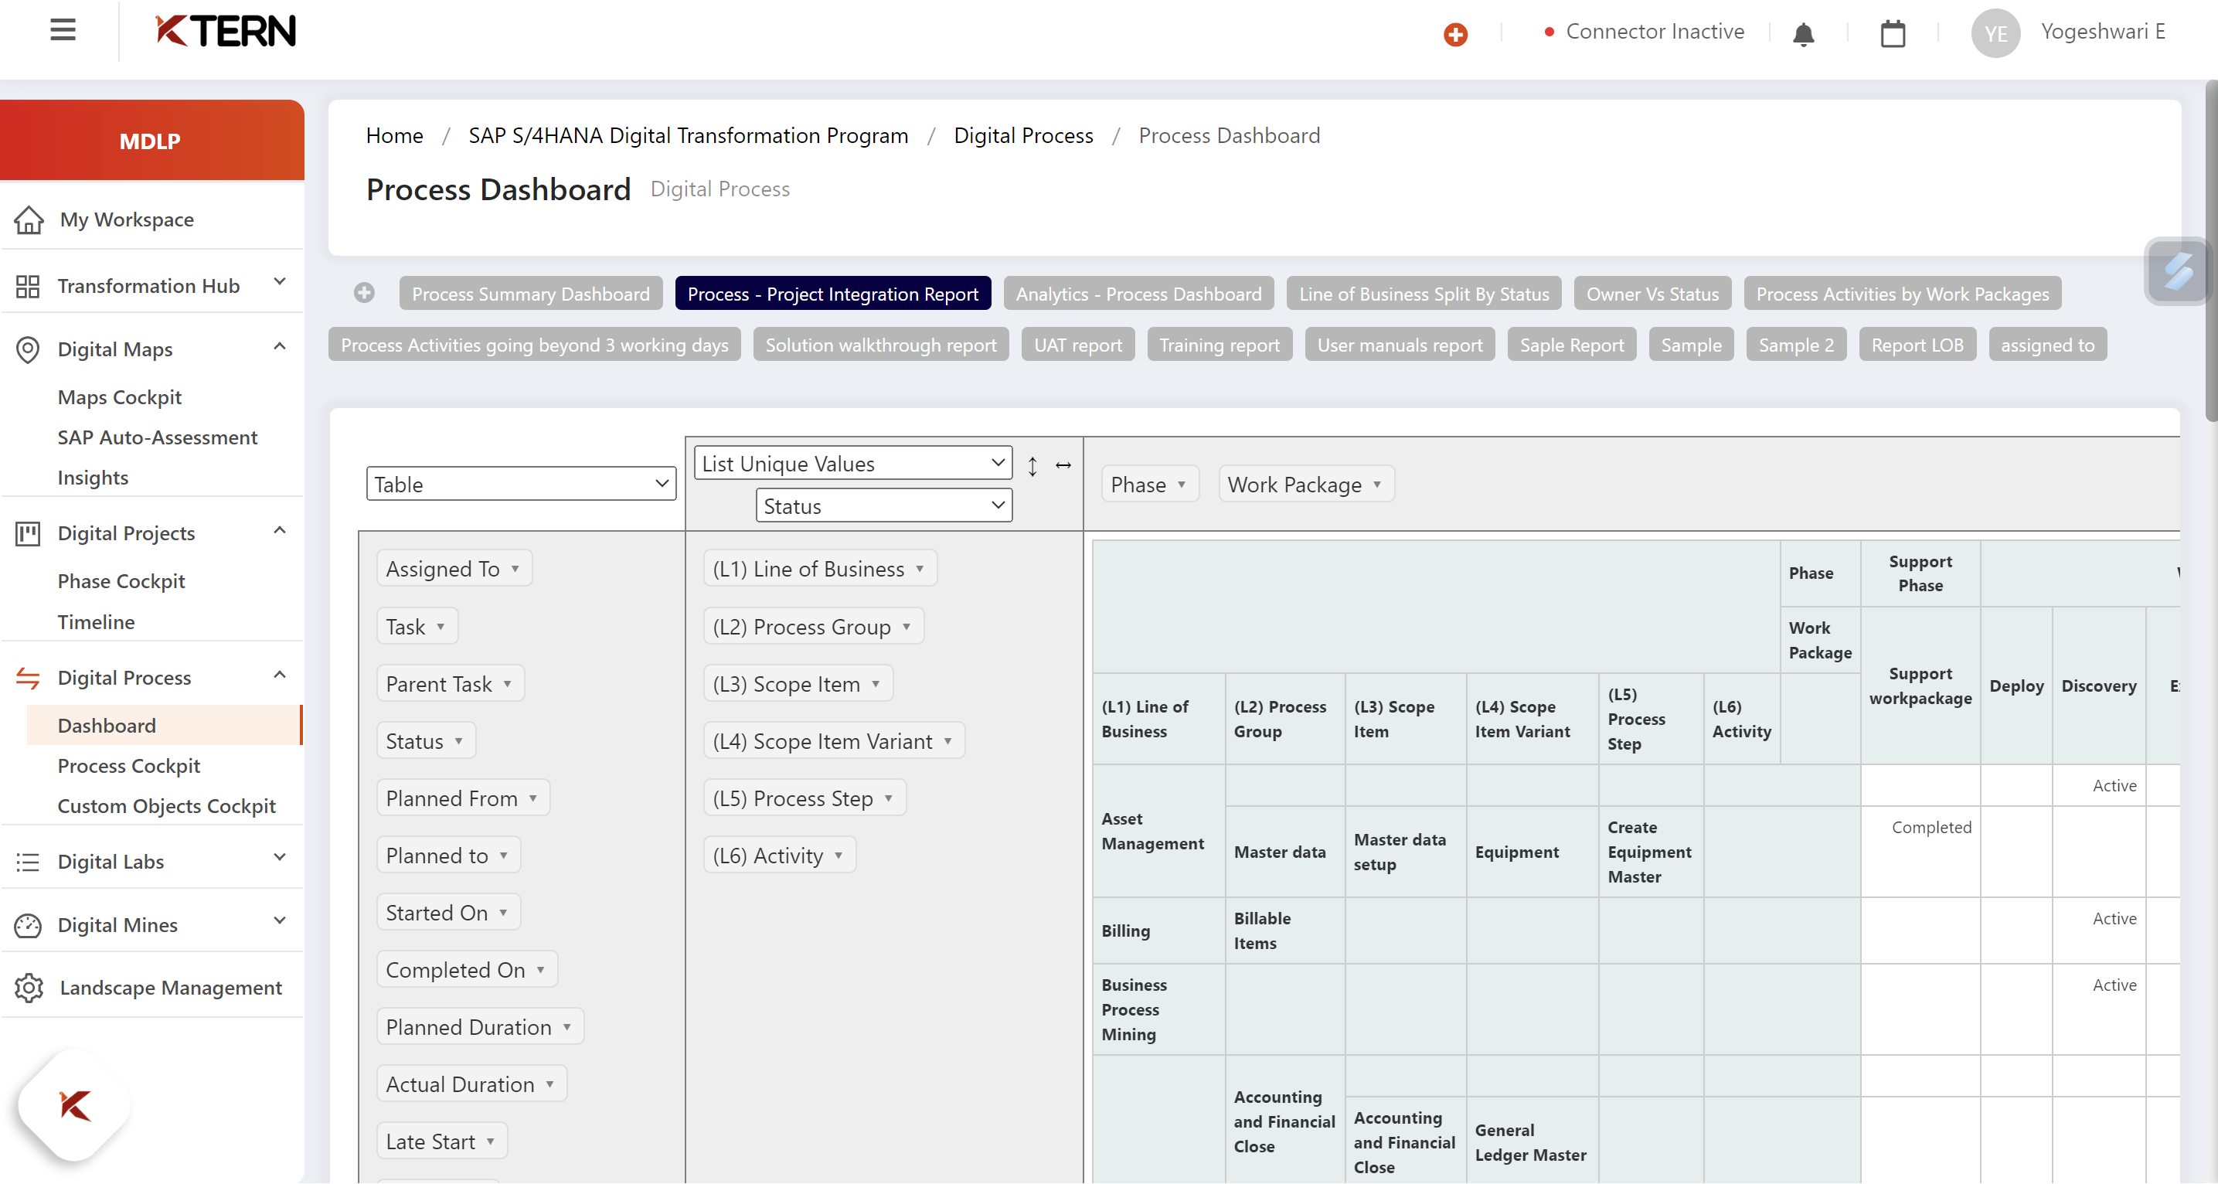

Process cockpit

Here we can create process cockpit and specify the type of process( successfully running without issues, running halted , testing completed, signed off and ready to run)

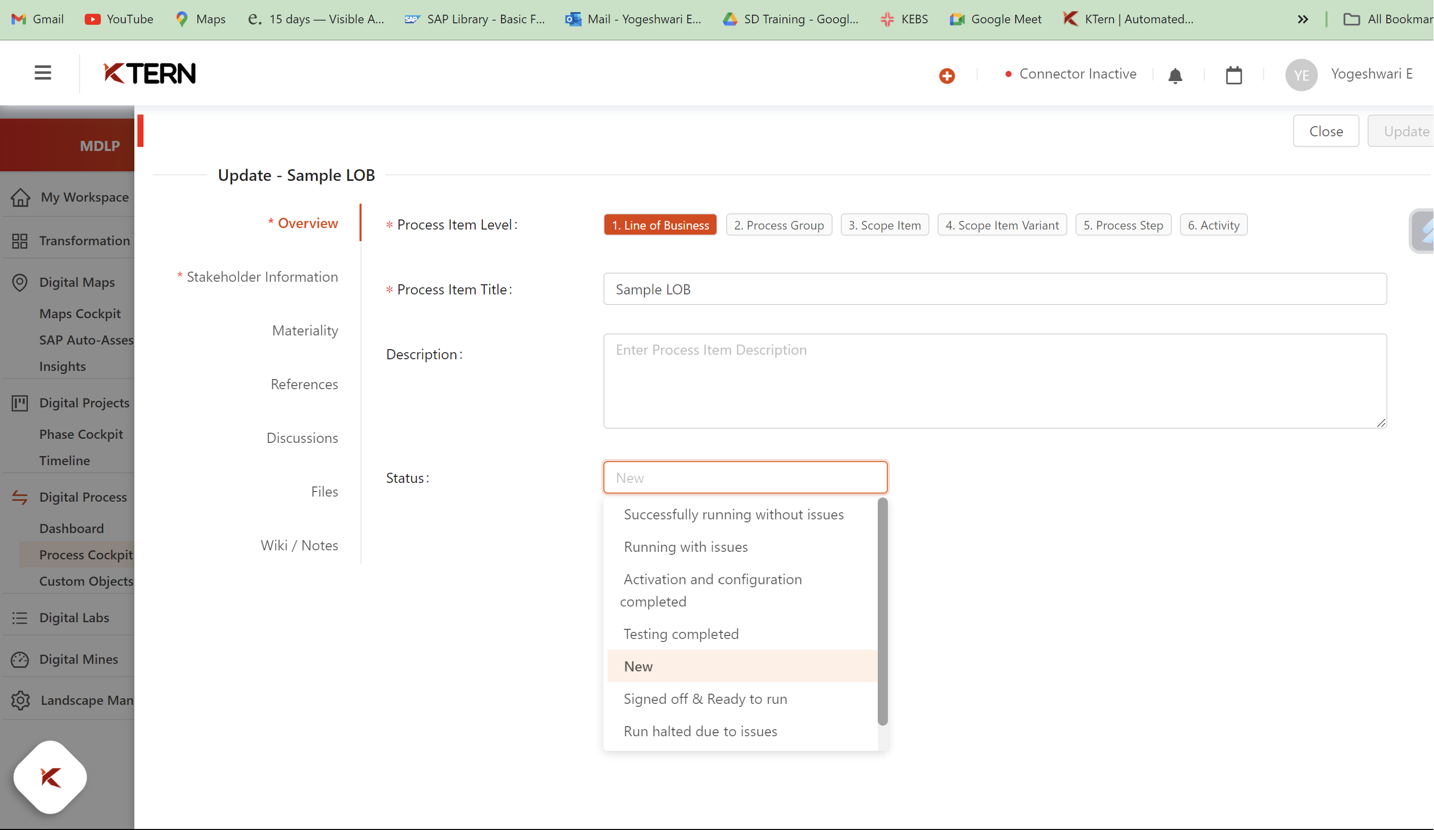

And it is listed in the process catalog

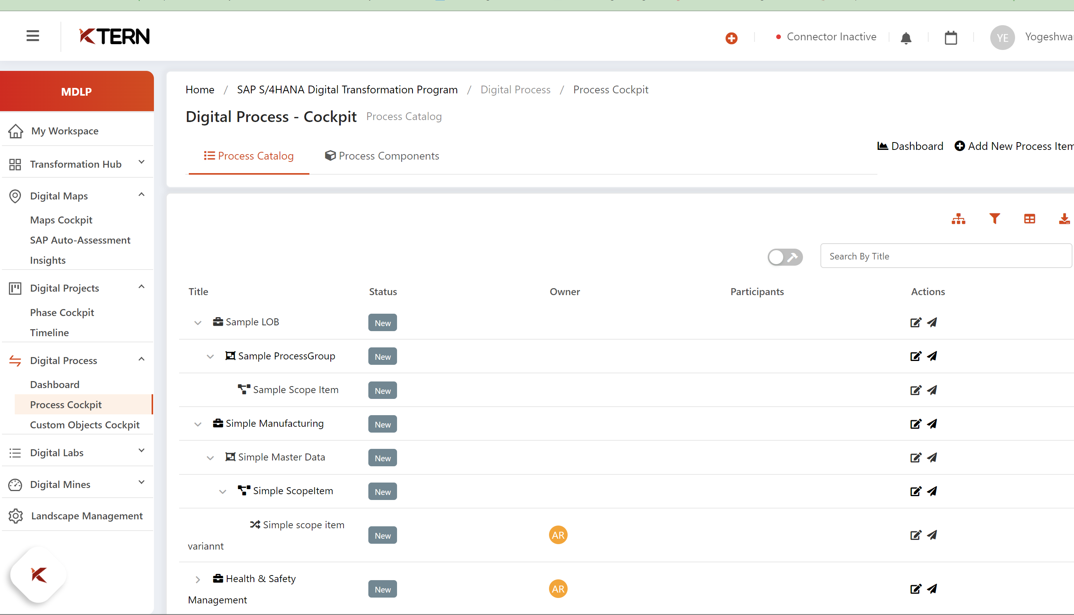

Digital labs

Digital labs is purely meant for testing purpose. Here we can see the testcases that needs to be tested and the defects that needs to be resolved.

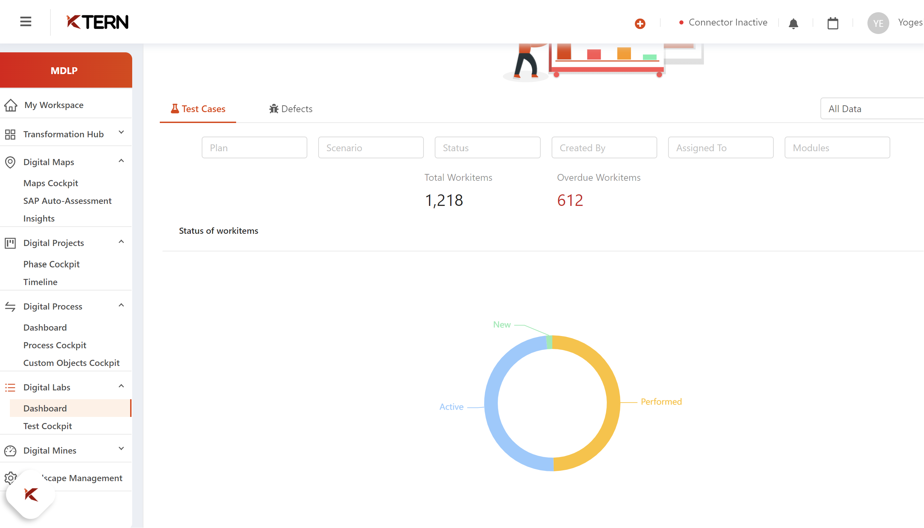

Test catalog shows the list of tests that needs to be performed and also indicated the level of priority based on its insights.

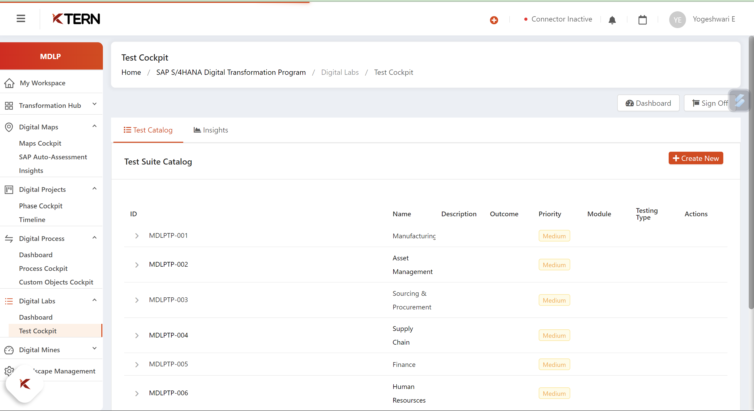

Digital mines

Digital mines is an AI intelligence release platform.

Analyses the effects of software changes, updates, and upgrades. It automates the release process and the steps, the guidance for releasing is generated.

